AOC AGM700 RGB Gaming Mouse
USER'S GUIDE
Ver.:1.00

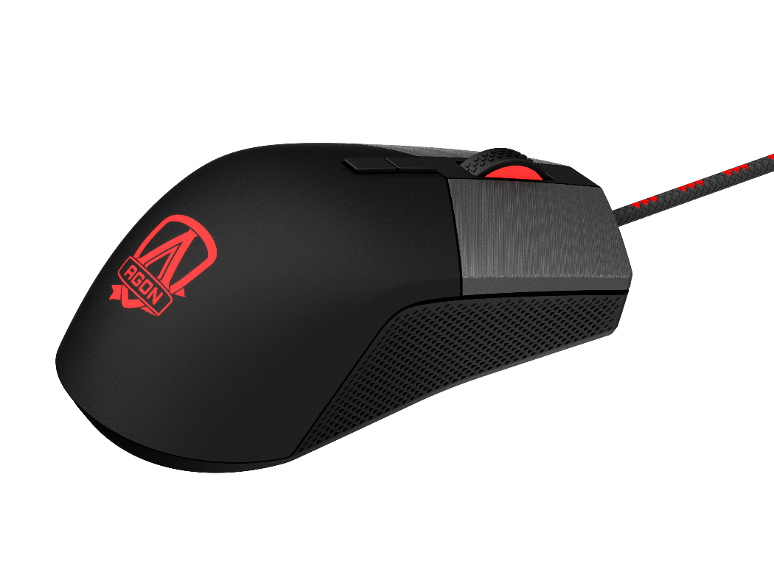

CAUTION: To use this product properly, please read the user's guide before installing.

Contents

- PACKAGE CONTENTS/SYSTEM REQUIREMENTS | 1
- TECHNICAL SPECIFICATIONS | 1
- DEVICE LAYOUT | 2
- AOC G-TOOLS INSTALLATION | 3
- AOC G-TOOLS INSTRUCTION | 4
- SAFETY GUIDE AND MAINTENANCE | 13

PACKAGE CONTENTS/SYSTEM REQUIREMENTS
Package Contents
- AGM700 FPS Gaming Mouse
- Five Pieces 5g Weight Module
- Quick Setup Guide

Product System Requirements
- Windows® 7/8/8.1/10 or macOS
- Available USB port
- 160MB free hard disk space
- Internet connection

AOC G-Tools System Requirements
- Windows® 7 or above
- 160MB free hard disk space
- Internet connection

Technical Support
- 2 years limited warranty
- Free online technical support at www.aoc.com

TECHNICAL SPECIFICATIONS
Specifications
- Advanced optical sensor with true 16000 DPI
- Switchable DPI - 1600/3200/6400/12800/16000/smart DPI (default 1600 DPI)
- Up to 400 inches per second (IPS) and 50g acceleration
- 8 programmable buttons
- Omron mechanical switch with up to 50 million clicks lifespan
- UP to 1000 Hz/1 ms report rate
- Enquired with weight module can easy for weight adjustment
- Customizable RGB lighting effect syncing with other AOC gaming devices
- 1.8 M braided cable

Approximate Size & Weight
- Length: 129.50 mm/ 4.95 in
- Width: 65.32 mm/ 2.57 in
- Height: 42.30 mm/ 1.66 in
- Weight: 173 g/0.38 lbs
- Cable Length: 1.8 m/ 5.9 ft

Operating Environment
- Operating Temperature: 0 ° C (32 ° F) to 40 ° C (104 ° F)
- Operating Humidity: 10% - 85%

Device Layout

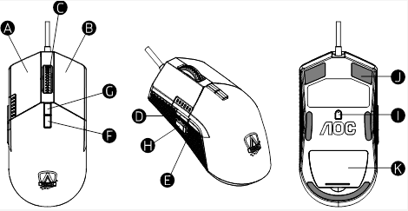

- Left Button
- Right Button
- Middle Button/Scroll Wheel
- Browser Forward
- Browser Backward
- DPI Cycle
- Mode Switch
- DPI Shift
- True 16,000 DPI Optical Sensor
- Smooth Mouse Feet
- Weight Module
AOC G-TOOLS INSTALLATION

Step 1: Plug the device into a USB port on your computer.

Step 2: The computer operating system will automatically detect the device.

Step 3: Download AOC G-Tools. Browse to http://www.aoc.com and search for "AOC G-Tools."

Step 4: Start the installation process by clicking on the file “Setup.exe”.

Step 5: Windows® will prompt you if installation should continue; install the driver despite this.

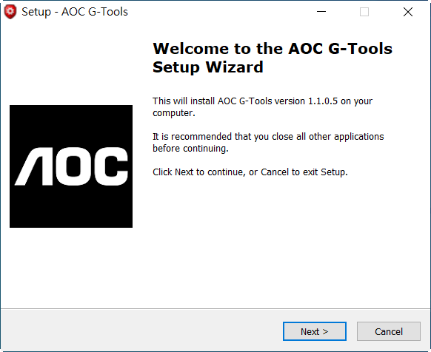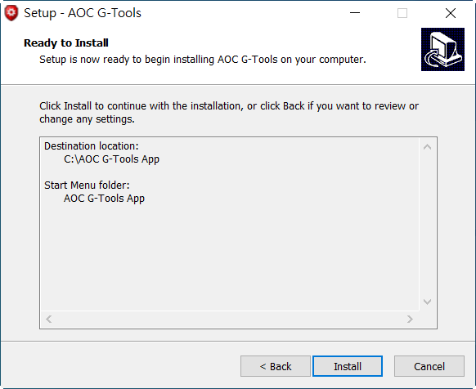

Note: The driver will automatically uninstall any previous version of the driver; for this reason, it may take some time for the driver to install before you may begin programming the device.

Step 6: When the installation process is complete, please reboot your computer system.

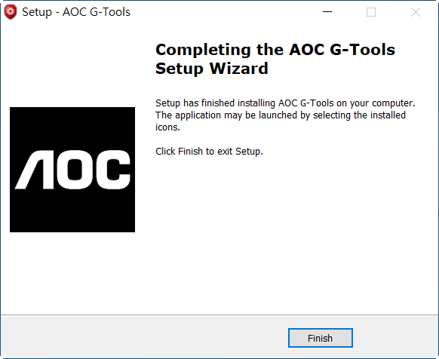
Step 7: The AOC G-Tools icon is displayed in the Windows® taskbar while it is running. Access the Configuration menu by right-clicking the AOC G-Tools icon.
AOC G-TOOLS INTRODUCTION
Game Profile Management
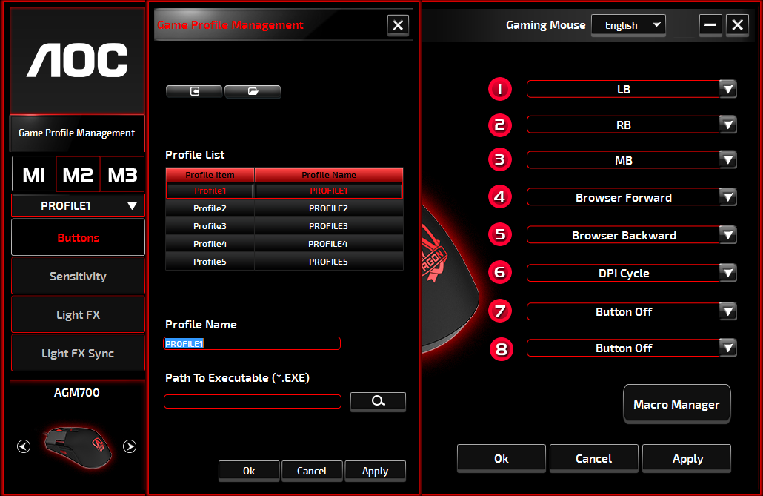

Under Game Profile Management, you may export a customized profile by clicking the Export button, or import a profile from your computer by clicking the Import button.

The default profile names are Profile 1 through Profile 5. You may rename your profiles by typing in the text field below Profile Name.

Each game profile supports seven macro keys, and the on-board memory of the device supports three profiles.

Each profile may be activated along with a linked program. To do so, put the executable path of the program you want to link in the Path To Executable (*EXE) text field.

Reset To Factory Default Settings
By clicking the ‘GO’ button, the device will be reset to the factory default settings.
Buttons
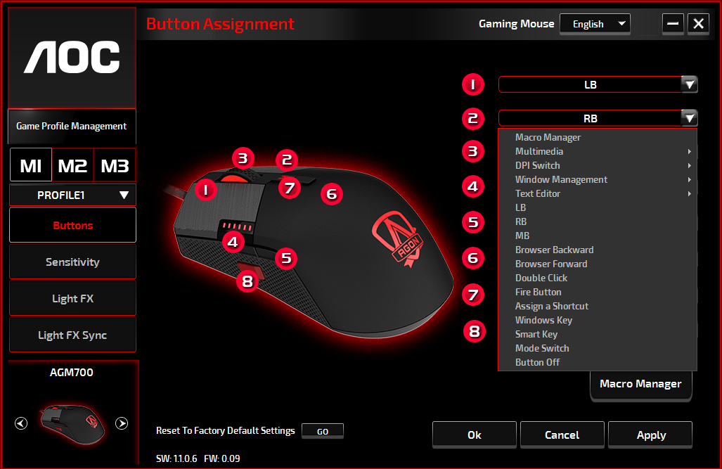

For each numbered button, you may assign an action from its drop-down menu. Options listed in the drop-down menu are explained below.
- Macro Manager
A macro is a prerecorded sequence of keystrokes and button presses executed with precise timing. By assigning a macro to a button, you can execute complex combinations with ease. The device allows you to create, delete, import, and export your customized macros. When choosing this option from the drop-down menu, the Macro Manager window will appear. You may select an existing macro as the assignment to the button, or record a new macro and assign it to the button. If you like to perform the assignment later, click the Macro Manager button in the lower right corner, the Macro Manager window will show for your further operations as below.

1. Create a Macro
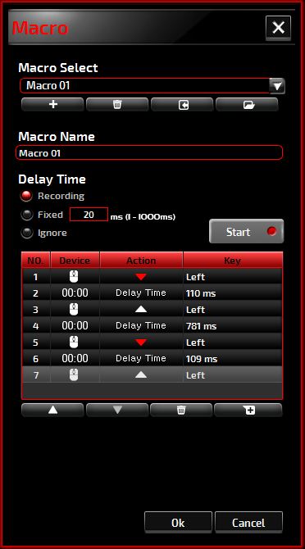
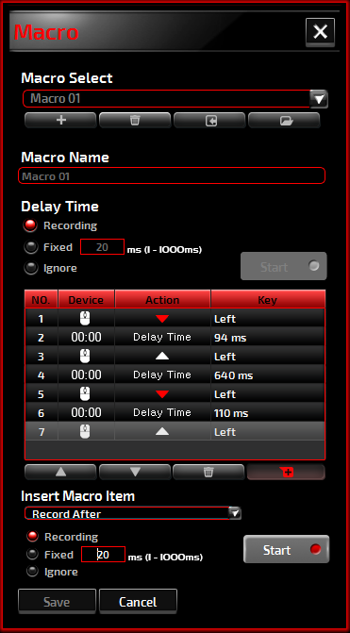
- Click the button and name the macro you are about to record. Confirm the name by pressing the Enter key on your keyboard.
- Set the delay time between events:
-Recording: The delay between events are registered as they are recorded.
-Fixed: Use a predefined time (shown in millisecond) for the delay.
-Ignore: Omit all the pauses between keystrokes and button presses.
- Click the Start button to record all your keystrokes and mouse button commands into the macro. When done, click the Stop button to complete this recording.
- Click the Cancel button if you want to discard this recording, or the Ok button to confirm this recording. Successfully recorded macros can be found from the Macro Select drop-down list.
- For any recorded macro, you may delete or adjust its event sequences, or add new events by initiating another recording session.
Note:
Each Macro key can record 64 actions (32keys).

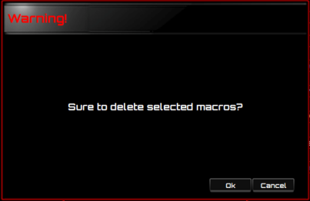
2. Delete a Macro
Select the macro to be deleted and click on the Trash Bin
button down below. A message window will pop up to confirm
your decision. Click the Ok button to delete the macro.

3. Edit Delay
To adjust the delay time, double-click the field to be revised and enter the new value. Some games may not be able to detect short delays.

4. Delete Record Actions
To delete a single or multiple actions or delay time of the macro, click the trash bin button.

5. Insert Macro Item
Click the button to start inserting another macro to an existing macro. Choose to record this new macro before or after the existing one; then click the Start button to start the recording. When done, click the Stop button to complete the session, or the Save button to keep the recording. You may also insert delay time before/after the selected event. After entering the desired time value, click the Save button.

- Multimedia
Open Player: Start media player.
Pre Track: Toggle to the previous media track.
Next Track: Toggle to the next media track.
Play/Pause: Toggle between playing and pausing media.
Stop: Stop playing the media.
Mute: Mute (turns off) the computer sound.
Volume +: Increase the computer sound volume.
Volume -: Decrease the computer sound volume.

- DPI Switch
DPI Up: Increase the DPI.
DPI Down: Decrease the DPI.
DPI Cycle: Cycle between the 5 options of the G-Tools.
DPI Shift: Predefined DPI at 400.

- Window Management
Calculator: Start Microsoft Calculator.
Email: Start the default mail program.
WWW Favorites: Open the default web browser Favorites.
WWW Forward: Go to the next webpage.
WWW Back: Go to the previous webpage.
WWW Stop: Stop loading webpage.
My Computer: Open the My Computer window (or This PC for Win10).
WWW Refresh: Refresh the current webpage.
WWW Home: Start the default web browser and load the homepage.
WWW Search: Go to the default web browser search bar or Search Windows.
Show Desktop: Switch between desktop and the current view.

- Text Editor
Nine text commands are available: Cut, Copy, Paste, Undo, Select All, Find, New, Save, and Open.

- Left Click
Perform a left-click.

- Right Click
Perform a right-click.

- Middle Click
Activate the universal scrolling function.

- Browser Backward
Perform "Backward" command for most Internet browsers.

- Browser Forward
Perform "Forward" command for most Internet browsers.

- Double-Click
Perform a double-click action.

- Fire Button
Perform a fire button until release.

- Assign a Shortcut
Assign a shortcut combination.

- Windows Key
Open the Start Windows menu.

- Smart Key
If you assign a button with Smart Key function, while holding down the Smart Key, press the other button, the Smart Key will repeat this button’s action continuously.

- Button Off
Switch off the button.

Sensitivity

- DPI Setting
You may define five sets of DPI values ranged from 200 to 16000 to suit your needs. The set DPI values will be applied to the DPI cycle function. When a set value is currently in use, it will be highlighted in red, and the corresponding LED color will be shown on your device.
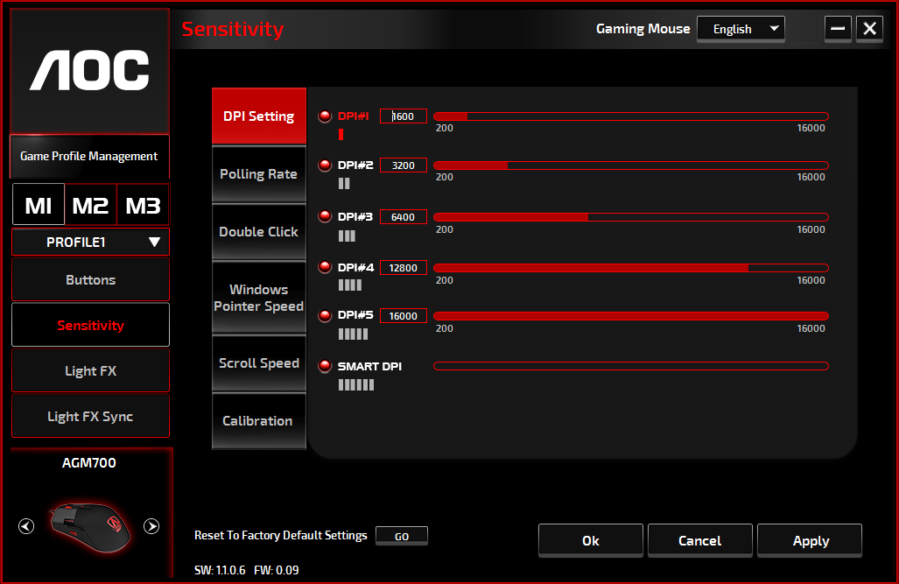
The default values are as below:
- DPI #1: 1600 DPI (Default)
- DPI #2: 3200 DPI
- DPI #3: 6400 DPI
- DPI #4: 12800 DPI
- DPI #5: 16400 DPI
- DPI #6: SMART DPI
- Polling Rate
Choose from four polling rate options: 125Hz/8ms, 250Hz/4ms, 500Hz/2ms, 1000Hz/1ms(default).
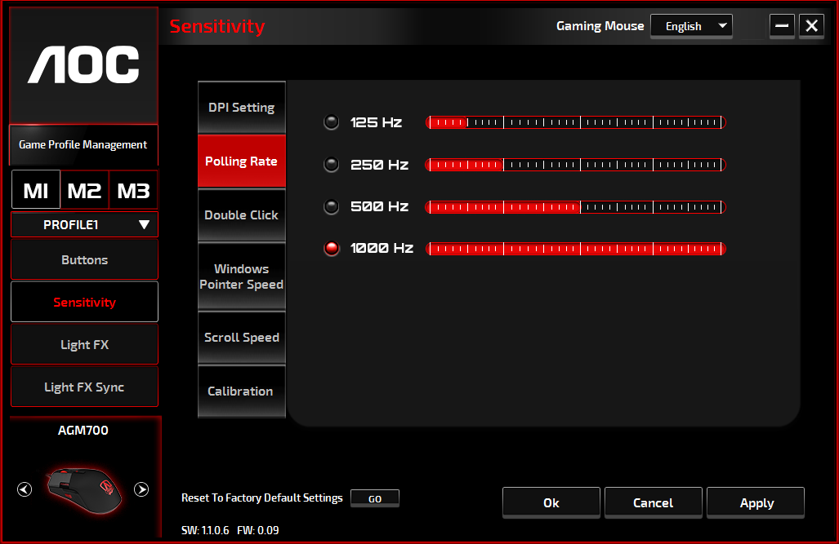
- Double Click
Drag the slider bar knob toward left (Slow) or right (Fast) to adjust the double-click speed.
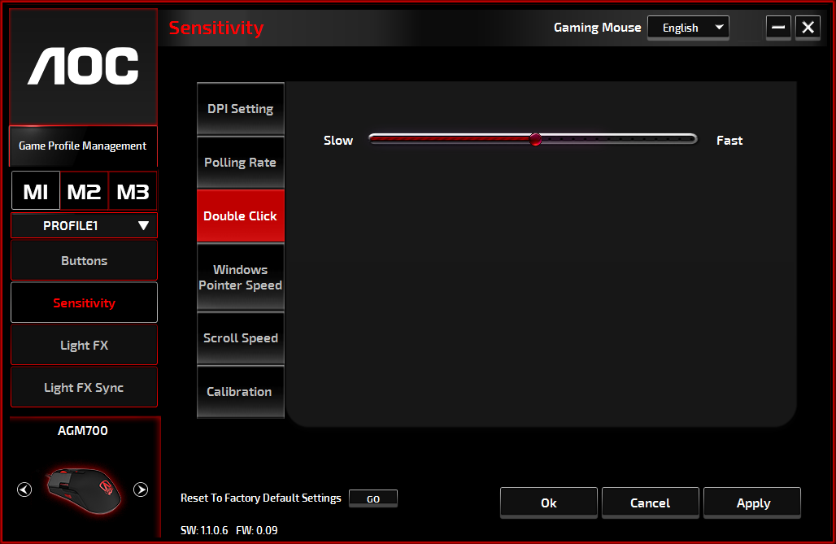
- Windows Pointer Speed
Drag the slider bar knob toward left (Slow) or right (Fast) to adjust the Windows Pointer Speed. The set value will also be applied to the Windows Control Panel. We recommend the default setting.
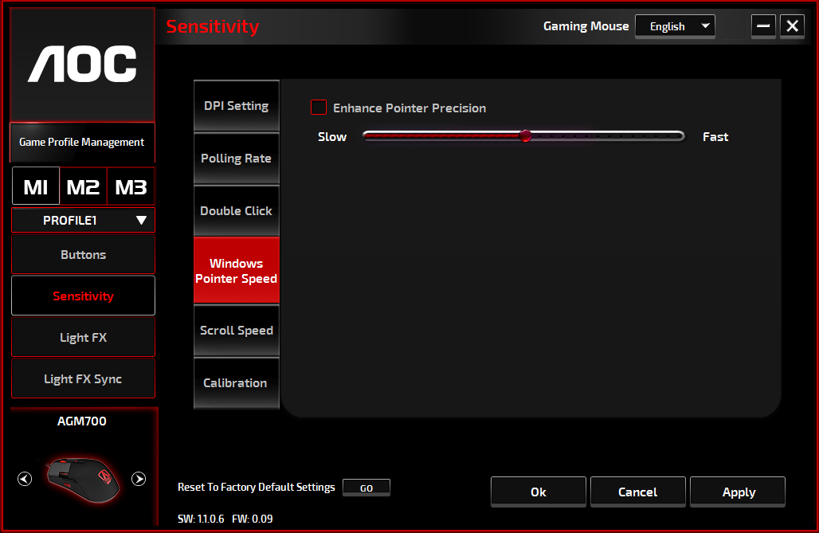
- Scroll Speed
Drag the slider bar knob toward left (Slow) or right (Fast) to adjust the scrolling speed for viewing a document or webpage. To test the set value, press the Apply button and test in your browser.
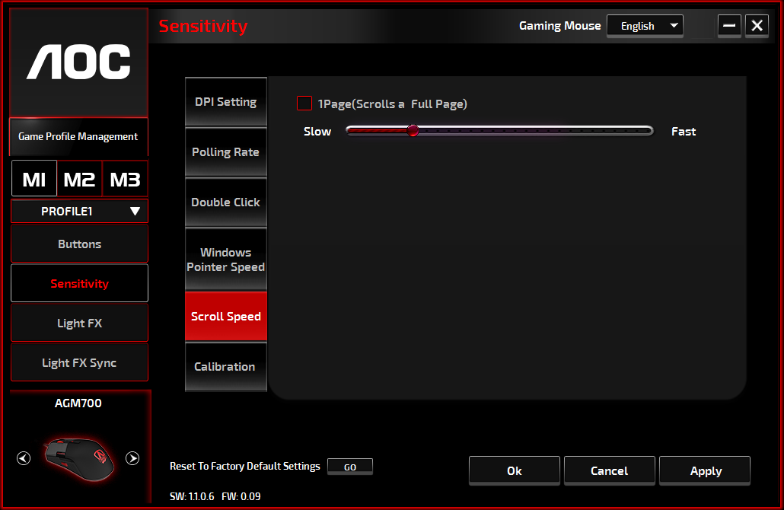

Light FX
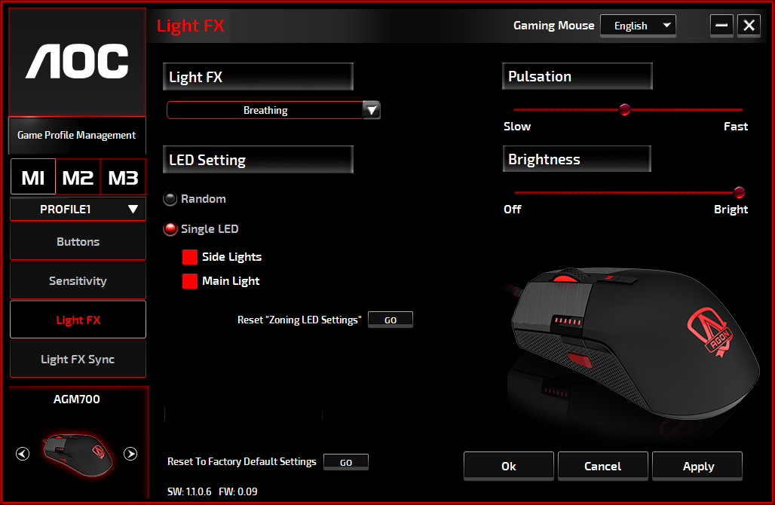
- Light FX
Choose from the Light FX drop-down menu for your favorite light setting. Options are: Static, Breathing, and Blink.

- LED Setting
Choose the Random or Single LED lighting effect option to set continuously changing colors or a selected RGB color for the device. To restore the default light settings, press the Go button beside “Reset To Factory Default Settings”.
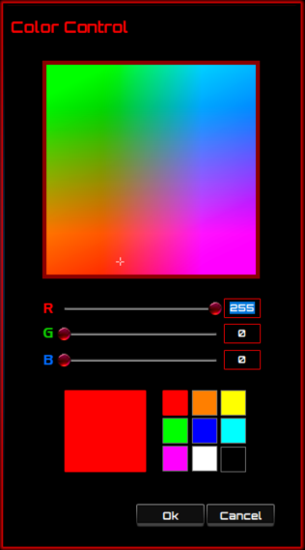
- Random:
Lighting colors cycle between 12 predefined colors.

- Single LED:
To set the color, click the color square next to the Side Light/Main Light option, the Color Control windows will pop up. Point at any spot on the RGB panel to set your favorite color, or enter RGB values to define the color. The LED color setting is available for Static, Breathing, and Blink effect.

- Pulsation
Drag the slider bar knob toward left (Slow) or right (Fast) to set up the speed of the lighting effect, three options are available from Slow to Fast.

- Brightness
Drag the slider bar knob toward left or right to set up the brightness of the lighting effect, four levels of lighting brightness are available from Off to Bright. This setting option is available for all of the lighting effects.

Light FX Sync

The lighting effect of the device can be synchronized with other AOC gaming devices that support the AOC Light FX Sync. To sync the devices, select the icons of the devices of your choice and click the Apply button. The synchronized devices are highlighted in red.

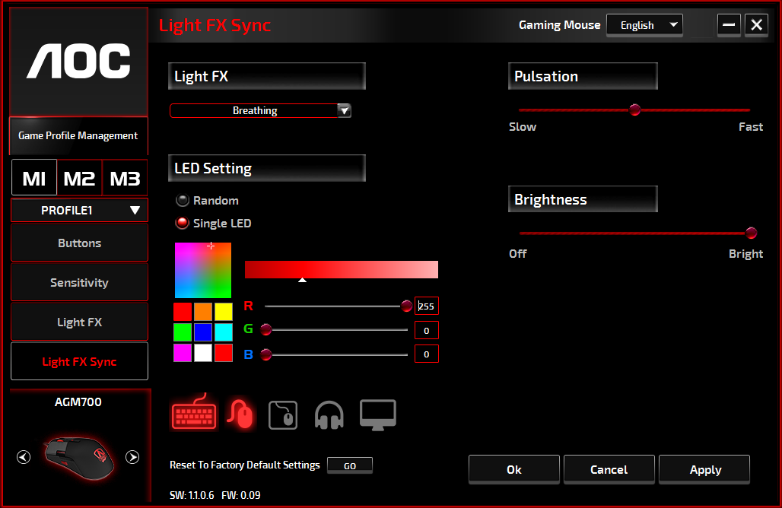

Reset To Factory Default Settings
By clicking the GO button, the device will be reset to the factory default settings.

Online Update

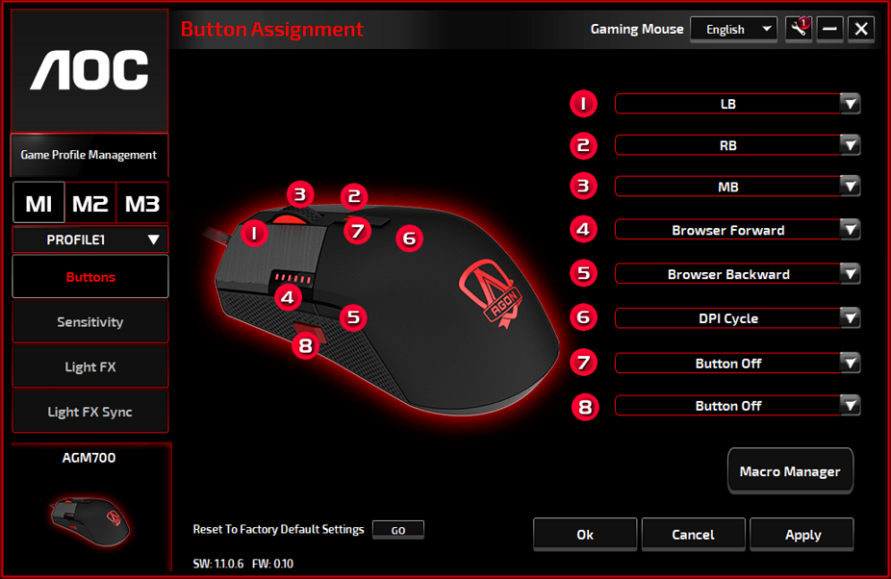
When there are new updates available, a notice balloon will show on the upper right corner along with the tool icon.
Click on the notice balloon, the Online Update pop-up window will show the update options. Select the updates to download and install. Click the Update button to complete the update process.
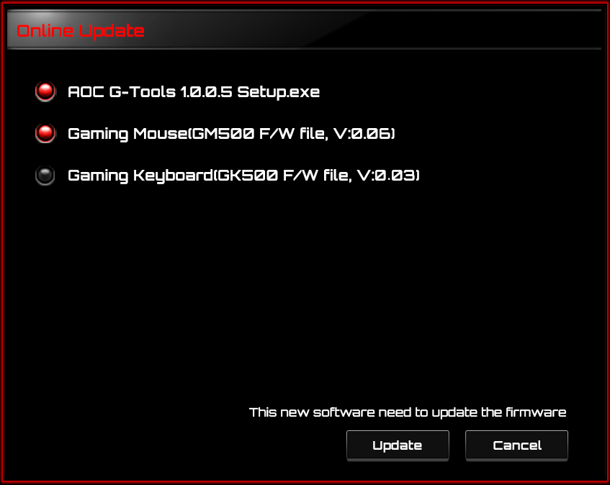
SAFETY AND MAINTENANCE
Important
For your safety, please carefully read the following guidelines for the device:
- Do not operate the device under abnormal conditions.
- Avoid looking directly at the device's tracking beam or pointing the beam at anyone's eyes. Please note that the tracking beam is not visible to the naked eye and is set as always-on.
- Do not disassemble the device (this will void the warranty) and do not attempt to operate under abnormal current loads.
- Keep the device away from liquid or moisture. Operate the device only within the indicated temperature range: 0 ° C (32 ° F) to 40 ° C (104 ° F). If the temperature of the device is too high, unplug the device to lower the temperature.
- If the RGB lighting is not running properly, or the device is not functioning, or if there is an abnormal thermal situation, troubleshoot the device by unplugging the device and plugging the device back in .
- If the troubleshooting process does not resolve the issue, unplug the device and visit www.aoc.com for support. Do not attempt to repair the device yourself.

Safety
Federal Communication Commission Interference Statement
This device complies with Part 15 of the FCC Rules. Operation is subject to the following two conditions:
(1) This device may not cause harmful interference.
(2) This device must accept any interference received, including interference that may cause
undesired operation.
Note:
This device has been tested and found to comply with the limits for a Class B digital device, pursuant to Part 15 of the FCC Rules. These limits are designed to provide reasonable protection against harmful interference in a residential installation. This device generates, uses, and can radiate radio frequency energy and, if not installed and used in accordance with the instructions, may cause harmful interference to radio communications. However, there is no guarantee that interference will not occur in a particular installation. If this device does cause harmful interference to radio or television reception, which can be determined by turning the equipment off and on, the user is encouraged to try to correct the interference by one or more of the following measures:
—Reorient or relocate the receiving antenna.
—Increase the separation between the device and receiver.
—Connect the device into an outlet on a circuit different from that to which the receiver is
connected.
—Consult the dealer or an experienced radio/TV technician for help.

